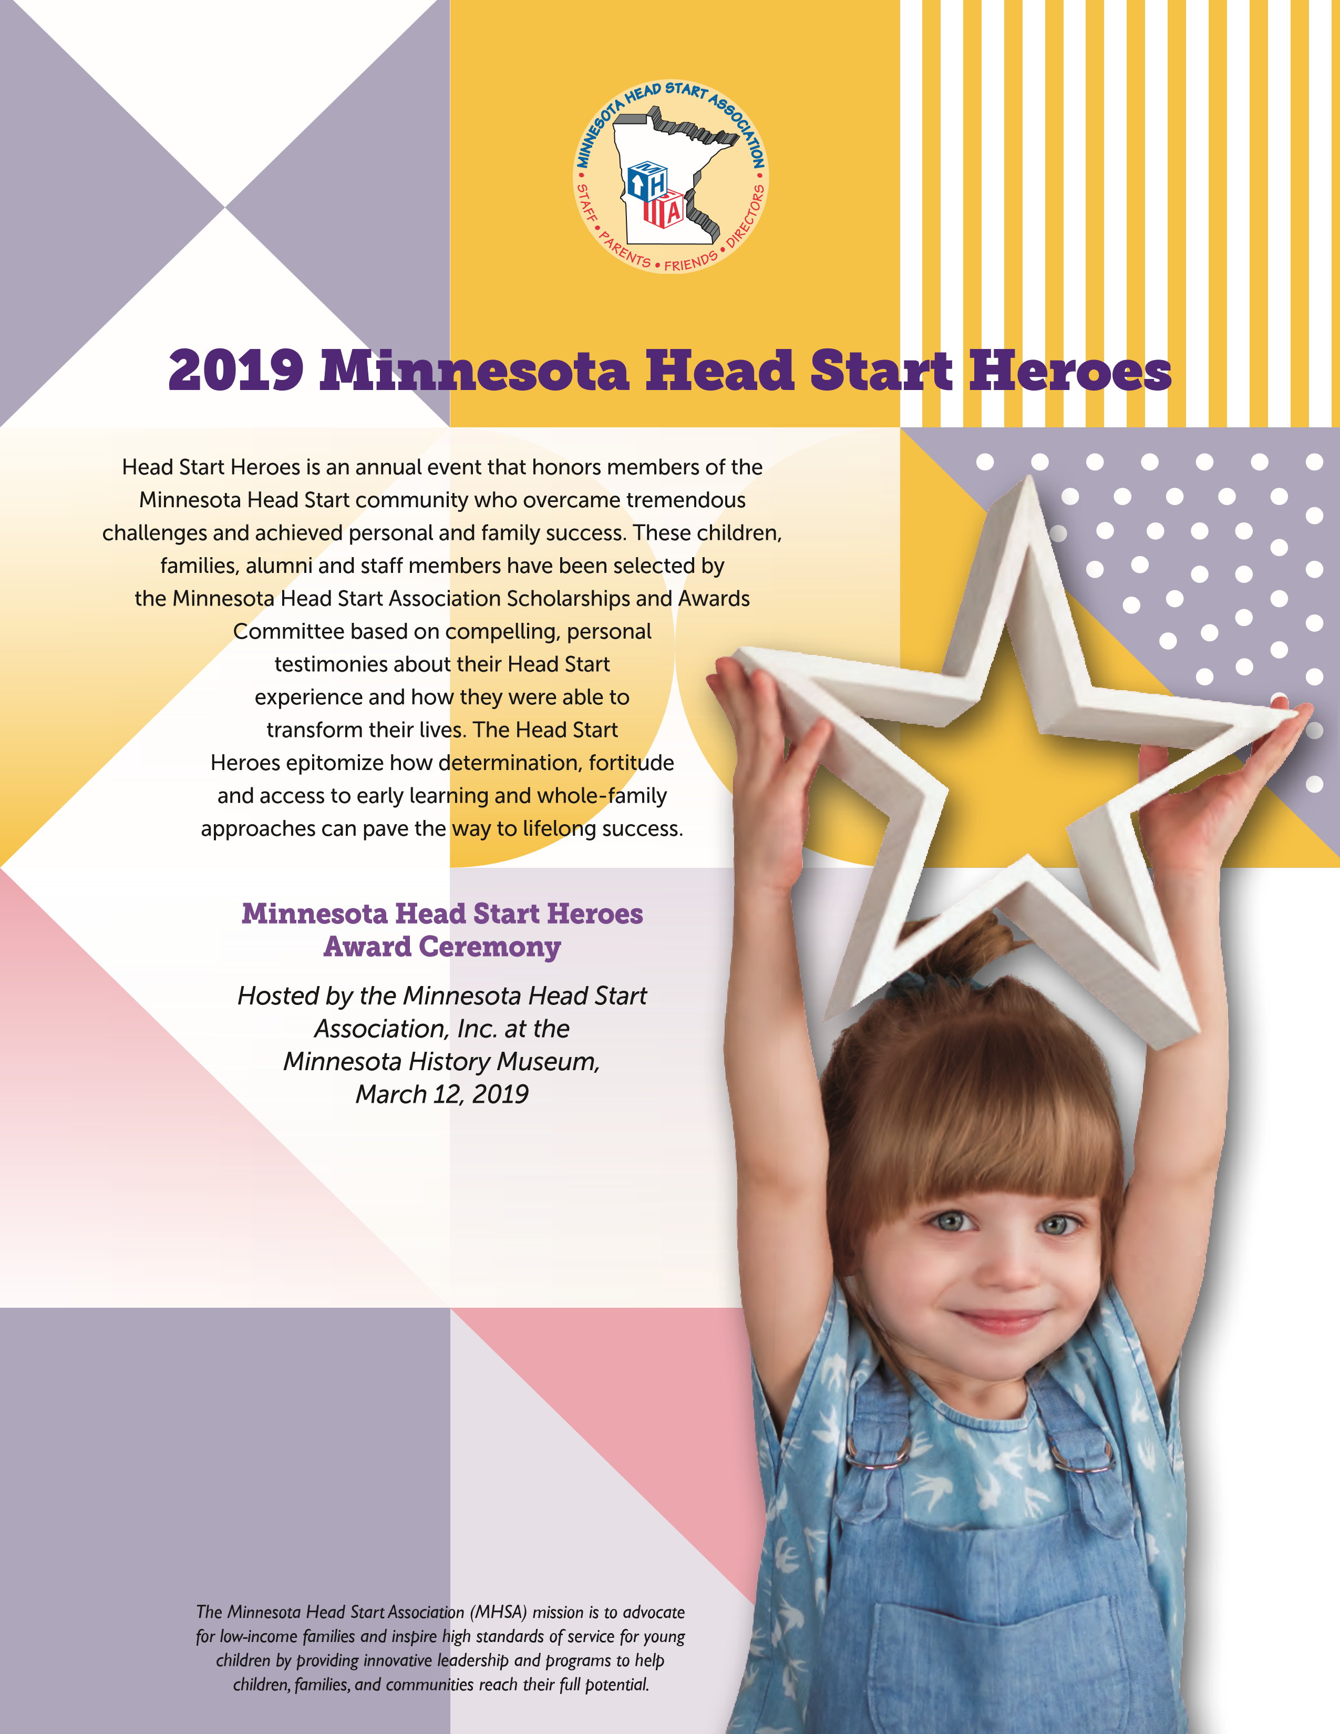

Tiffany Sullivan
Lakes & Pines Community Action Council
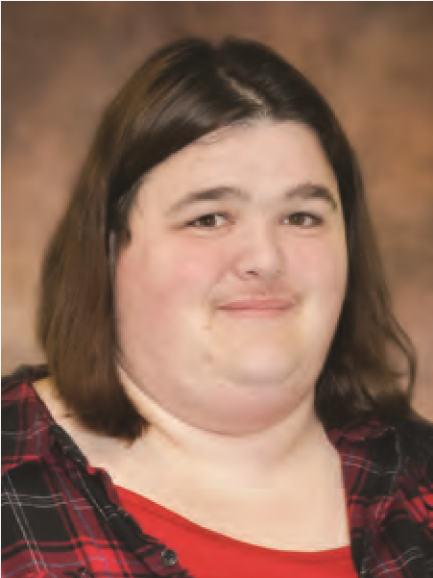 | C A T E G O R Y 1 W I N N E R  Head Start alumni who has become involved in their local program as a staff member and demonstrates a passion for serving through advocacy, career growth, or being involved in Head Start, the community, or the state/national level that benefits Head Start families.
Tiffany moved to Chisago City with her 2 ½ year old son running
from an abusive relationship and knew no one in the community. After seeing a brochure at a
local public health office, she applied for Head Start services.
When she became pregnant at 18 she was worried that she would not be able to keep her child and she has fought for him every day. She had major complications with his birth and almost lost her life during delivery, due to congestive heart failure.
She and Logan participated in the home based program for three years. She was encouraged to do fun activities with home materials to help teach Logan and was introduced to great families
in their area.
As a parent, Tiffany served on Policy Council, the MHSA Parent Affiliate, volunteered in the classroom and as an intern. She attended Parent Trainings, went to the State Capitol to advocate for Head Start. Being able to share her story helped her feel empowered to advocate for the best life for her son. After Logan went to kindergarten, she was offered an opportunity to volunteer in the classroom. It was then suggested that she go back to school in order to continue her work in Head Start. She worked full time at a local gas station and attended school to achieve her Associate Degree.
Tiffany became a member of the Head Start staff, serving as a 0–3 Home Visitor, then a Childcare Lead. She would spend several years building relationships with partners and families. Eventually she went back to school to obtain her Bachelor’s Degree in Early Childhood. In 2018, after 9 years at Lakes & Pines, she was offered the position of Education Coordinator.
“I am hoping to write a book someday with the great things that Head Start has done to build confidence in me and how that has helped me be a better mom for my son. After being told I was not good enough my whole life I can finally say I CAN and I WILL Accomplish anything,” says Tiffany.
Brian Andrews & Mandy Miller
Tri-County Community Action Partnership
C A T E G O R Y 2 W I N N E R
Head Start family who has made significant life changes within the past 12 months and is currently enrolled in a Head Start or Early Head Start program or is serving on a Policy Council.
Brian and Mandy Miller have been together for 18 years. Between the two, they have 6 children, 3 of which have attended Head Start. They had been friends for years,
but at first their relationship did not go further & they separated. They were re-united in recovery
in 2000. They started a long distance relationship over the phone. Their relationship grew and
soon they were expecting a child.
Brian started school, got a job as a gas station manager while Mandy worked seasonal jobs. They bought their first home together. Brian was involved with speaking engagements about his meth use. Because times seemed to be good, they both quit NA/AA and going to church.
However, Mandy lost her job and followed up with the birth of Isaiah. Unfortunately, he was stillborn and had to be revived. This resulted in many health issues. This traumatic beginning was enough to trigger Brian’s addiction relapse. Mandy quickly followed suite. When Isaiah started Head Start they were using on and off, but trying to stay clean. Isaiah’s attendance was inconsistent and many of the goals they set with their staff were just made up in order to “be
done.” In complete denial about their drug problem, they lost their house.
As their drug use spiraled, they had another child, Kael, and their older children began taking care of the younger ones. Their oldest daughter went to live with Mandy’s ex-partner to escape the chaos. Having their lives spiral out of control from drug and alcohol use, eventually the police arrive to arrest them, spending some time in jail, and temporarily losing custody of their children.
Following their jail stay, they were invited to a church. From there they worked to meet all the conditions to get their kids back, worked to find a home, and get their lives back in order. Brian went to Teen Challenge, eventually becoming an employee.
As they worked to find a home, they struggled due to their eviction and drug history. Finally finding a small home. They welcomed their 5th child. Mandy began to work seasonal jobs again to make ends meet. This time when Kael was enrolled in Head Start, they worked with staff to set and attain goals, seriously, to move ahead and fulfill their dreams. They applied for and were awarded a Habitat for Humanity home. Mandy found full time work as a professional Peer
Support specialist. With help from God and support from area resources including Head Start,
the family has been able to move forward and use the road they have traveled to inspire others.

Edward Hernandez-Mendiola
Parents In Community Action, Inc.
C A T E G O R Y 3 W I N N E R
A currently enrolled Head Start or Early Head Start child who has made tremendous developmental progress.
When Edward started Early Head Start on May 6, 2016, he was an
outgoing and curious little boy who got along well with his peers and made good developmental
progress. Unfortunately Edward began experiencing some unexpected health issues that affected
him both physically and developmentally, causing distress and impeding his progress in Early Head Start. Edward’s health issues began with a severe skin rash, and he was later diagnosed with seizures. Edward was uncomfortable and unable to focus on learning and play. His parents struggled to co-parent, moving between two households with doctor visits and medications was exhausting.
Edward’s entire team worked closely with him and his family to get him back on track. Edward experienced several paramedic calls and overnight hospital stays, but he never gave up. Edward
has made great gains in his cognitive, physical and social-emotional development. Edward was
recently diagnosed with epilepsy, allowing his medical providers to more accurately target his treatment and reduce multiple medications to just one.
Edward, now a preschooler in Head Start, is attending school regularly, learning something new everyday, playing with his peers and is on the path to becoming a successful Kindergartner.

Juanita Wilkes
Tri-Valley Opportunity Council
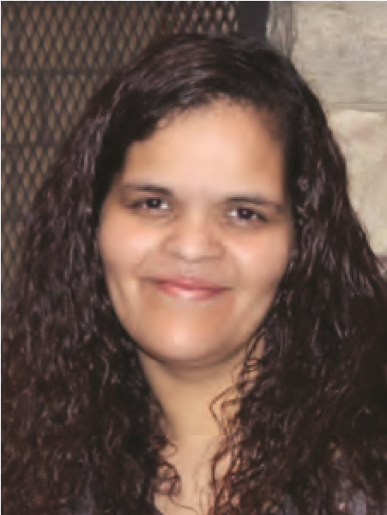 | C A T E G O R Y 4 W I N N E R  Head Start alumni who has demonstrated advocacy by becoming involved in their local program or community, such as Policy Council, their agency’s governing body, a parent committee/board at their public/private school, leadership in a local organization, etc.
Juanita is a single mother of 4 children, Juan (12), Audriauna (11),
NaTonja (8), and Gi'anna (3). She has been with the Head Start program for over 10 years.
Her journey started in the pregnant women’s program when she was expecting her first child.
“Head Start has given me a sense of belonging to the community. I feel my Head Start center is a community of selfless and genuinely caring people; we are a team,” says Juanita. Having
a team is important to her family because three of her children have special needs, including autism, ADHD, Congential Kyphosis, Episodic Mood Disorder and PTSD. With the help of early intervention services, she learned about their needs and how to address those needs appropriately. With the support of her team, she was able to balance working and caring for her children. She wanted to do more.
She is in her 5th year of serving on Policy Council, and is currently the President. At first, she was unsure of balancing all of this while continuing to work through the aftermath of the tragedy that her family had endured. She loves advocating for families just like her. She has also spent some time as Ad Hoc to the Board, led a voter registration campaign for the whole program, and was recently elected to the MHSA Board of Directors. These opportunities have allowed her to advocate for her own children as well as the other children in the program.
She has taken advantage of training opportunities, went to Washington DC with other Policy
Council members and staff from MN. “It was such an honor to do Hill visits and attend a Head Start rally! I feel my journey with Head Start has helped me gain a strong backbone and handle difficult situations that occur in my life. I now know I have a voice and it matters!”

Krystle Jensen
Inter-County Community Council
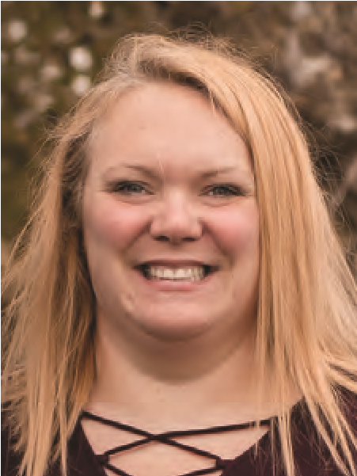 | C A T E G O R Y 5 W I N N E R  Head Start alumni that is going on to achieve their educational goals by attending an institution of higher education.
Krystle has been involved in Head Start for the past 4 years with
Inter County Community Council. She attends parent meetings, conference, and family events. She has recently become a member of Policy Council.
Krystle is currently attending Bemidji State University, pursuing a Bachelor’s Degree in Elementary Education.
Her goal is to work as an elementary teacher at one of our area elementary schools. She would also like to go to Honduras and use her elementary education degree to teach disadvantaged children. She would, eventually, like to get her Master’s Degree in reading intervention and possibly teach at the college level.

Gavin Davy
Northwest Community Action Agency
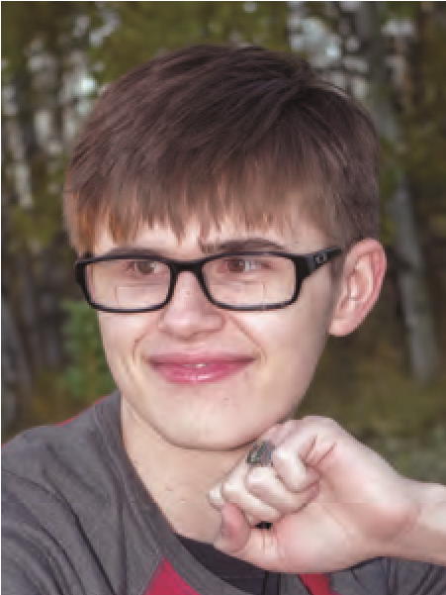 | C A T E G O R Y 6 W I N N E R  Head Start alumni (high school senior) that is going on to achieve their educational goals by attending an institution of higher education.
At six months old, Gavin was diagnosed with bilateral retinol
blastoma, causing complete blindness in his right eye and partial blindness in the left eye. He has been cancer free for over 13 years. He participated in Northwest Community Action
Agency’s Head Start program as a 3 year old. “Because of my strong educational foundation, I have developed the skills that have helped me to become the honor student and role model that I am today.” He is now prepared to graduate from Badger High School.
Gavin will be attending the University of Minnesota-Crookston, pursuing a Bachelor’s Degree in software engineering.
“My limited vision has not limited my goals.” Gavin would like to use his studies to learn more about computers and understanding the software that they run.

We would like to acknowledge those listed below who applied and were considered for the
Head Start Heroes Awards but were not selected. Every story was unique and inspiring, making
the decision very difficult. On behalf of children and families across Minnesota and the nation,
we thank you for your passion and advocacy, as it truly demonstrates that Head Start works!
CATEGORY ONE:
Head Start alumni who has become
involved in their local program.
>
Ashley Hesse,
Bi-CAP

>

Ashley Vocelka,
Mahube-Otwa Community Action
Partnership
>
Maria Alder,

Mahube-Otwa Community Action Partnership
>

Tomasena King-Hage,
Lakes and Pines Community
Action Council
CATEGORY TWO:
Head Start family who has made
significant life changes within the past 12 months.
Alisha Guerrero,
>
Inter-County Community Council
>
Kala Sawyer,
Tri-County Community Action Partnership
Krystal Watts,
>
Bi-CAP
Lucia Medina,
>
Inter-County Community Council

>

Sirena Samuelson,
Lakes and Pines Community
Action Council
CATEGORY THREE:
Head Start child who has made
tremendous developmental progress.
>
Courtlynn Menk,
Tri-County Community Action Partnership
>
Joshua Myint,
United Community Action Partnership

>
Casey Monk,
Tri-Valley Opportunity Council
CATEGORY FOUR:
Head Start parent alumni who is going
on to achieve their educational goals by attending an
institution of higher education.
>
Angela Okafor,
Parents In Community Action, Inc.
>
April Menk,
Tri-County Community Action Partnership
Brandee Grabau,
>
United Community Action Partnership
>

F
rances Gail Weidenbach,
Mahube-Otwa Community
Action Partnership
Kristina Stone,
>
Tri-County Community Action Partnership

>

Laurie Knutson,
Community Action Partnership of Lakes
and Prairies
CATEGORY FIVE:
Head Start alumni who is going on to
achieve their educational goals by attending an institution
of higher education.
>

Ashley Schwartz,
Community Action Partnership of Lakes
and Prairies

>

Ashton Johnson,
Tri-County Community Action Partnership

>

Danielle Mary Hawks,
Mahube-Otwa Community Action
Partnership

>

Laura Hahn,
Northwest Community Action Agency
>

Ruby Gar
cia,
Semcac

>

Tina Bocanegra,
Lakes and Pines Community
Action Council
>

Zakaria Amin,
Community Action Partnership of Lakes
and Prairies
CATEGORY SIX:
Head Start alumni (high school senior)
who is going on to achieve their educational goals by
attending an institution of higher education.
>

Angel W
eidenbach,
Mahube-Otwa Community Action
Partnership
>
Anna Paul, M
ahube-Otwa Community Action Partnership

>

Aujanae Eubanks,
Community Action Partnership of Lakes
and Prairies
>
Bailey Wynn,
Bi-CAP
>
Emma Haugen,
Duluth Head Start
>
Foney Marcellino
>
Jasmine Walraven
>
Jenna Boushee,
Tri-Valley Opportunity Council
>
Kiah Walker,
Tri-County Community Action Partnership
>
Mackenzie Lampton,
AEOA
>
Marie Johnson,
Inter-County Community Council
>
Nathan Hirte,
West-Central Community Action
>
Taylor Dorschner,
United Community Action Partnership
Minnesota Head Start Association
904
Valley Drive, Duluth, MN
55804
218.728.1091

info@mnheadstart.org

