Minnesota Head Start Facts 2020 | 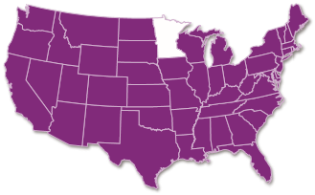
Minnesota Head Start Elementary Extension Study
Since 2011, the Minnesota Head Start Association (MHSA) has supported local Head Start programs to aggregate child and family data to support continuous quality improvement. In addition to providing real-time data analysis to inform annual child progress, the MN Head Start School Readiness Goals Project maintains 9 years of archived data on 4 year olds exiting Head Start.
In the Fall of 2018, participating programs boldly set out to learn how
Head Start children were doing after leaving Head Start. Over 20,000
Head Start 4 year olds’ data were matched to their K-3 data in the Minnesota Automated Reporting Student System (MARSS) and Minnesota Comprehensive Assessment (MCA-III). The primary research question: What can be learned from public education administrative data about the early elementary school experiences of Head Start children?
The study looks at children’s attendance, 3rd grade MCA data and identification for special services. The Head Start children transitioned into nearly 1,200 different Minnesota elementary schools (or 463 school districts). “School Peers” from the same schools who were eligible for free or reduced-price lunch and had similar characteristics served as a best-fit comparison group. Key findings indicate Head Start children are on par with their School Peers (who are in fact more advantaged) on measures like math and reading, and outperform their peers on attendance.
This study was made possible by the Minnesota Head Start Association, Inc. in partnership with the Minnesota Department of Education and funding from a grant from the Otto Bremer Trust. Dr. Matthew Hendricks, PhD and Gayle Kelly, M.S. served as primary investigators, in collaboration with staff from Early Learning Services Division, Minnesota Department of Education.
Study Design: By the Numbers

20,000
Head Start 4 Year Olds

1,200
Minnesota Elementary Schools
300 ,000
School Peers

Key findings from the Minnesota Head Start Elementary Extension Study Include:
Beating the Odds: Head Start Starting Early with Head Start: Attendance Matters: The Head
children’s performance on 3rd grade Children with two years of Head Start Start sample had significantly better math and reading assessments were (HS) or Early Head Start (EHS) achieved attendance than their School Peers. comparable to their School Peers. higher 3rd grade scores than those Children with high attendance in Minnesota educational data suggests with just one year of Head Start. On Head Start continued to have better children who are racially diverse, speak a average, multilingual learners with attendance in K-3. Children with high language other than English at home, have two or more years of HS/EHS passed attendance (over 90% attendance) in a diagnosed disability or live below the Minnesota’s English Proficiency Exam Head Start outperformed their School
poverty line are at risk of becoming part of (ACCESS) slightly earlier than their Peers on both 3rd grade math and
Minnesota’s achievement gap. The Head School Peers. reading assessments, scoring higher Start sample more often reflected these ^{on both measures.} characteristics than their School Peers
(Table 1). In spite of these challenges, the 1 The MARSS data provides no comparable indicators of family income or social economic status
(SES) available in the Head Start data. Head Start income eligibility is set at 100% of poverty findings of the Extension study shows ($25,100 for a family of 4 in 2019). Free or reduced price lunch (eligibility at 130–185% of Head Start children are performing on par poverty, respectively) were the only proxy available to control for family income and potentially with their higher income School Peers.¹ underestimates Head Start children’s true performance compared to their School Peers.
TABLE 1: CHARACTERISTICS OF THE STUDY SAMPLE IN K-5

(
N

=

child-years)
■
Head Start

–

72
,829
■
School Peers

–

933,987
79
%
%
34
54
%
33
%
22
%
12
%
25
%
17
%
Identified for
Special Ed
Identified as
Multilingual
Learners
Race:
Non-white
Free Lunch
Eligible
Minnesota Head Start  Elementary Extension Study | 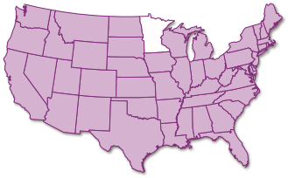
For more information contact:
Minnesota Head Start Association, Inc. Joelle Hoeft, Executive Director
www.mnheadstart.org o: 763.208.7272 c: 763.544.1992
New Address:
PO Box 27851, Minneapolis, MN 55427-9998
joelle@mnheadstart.org

