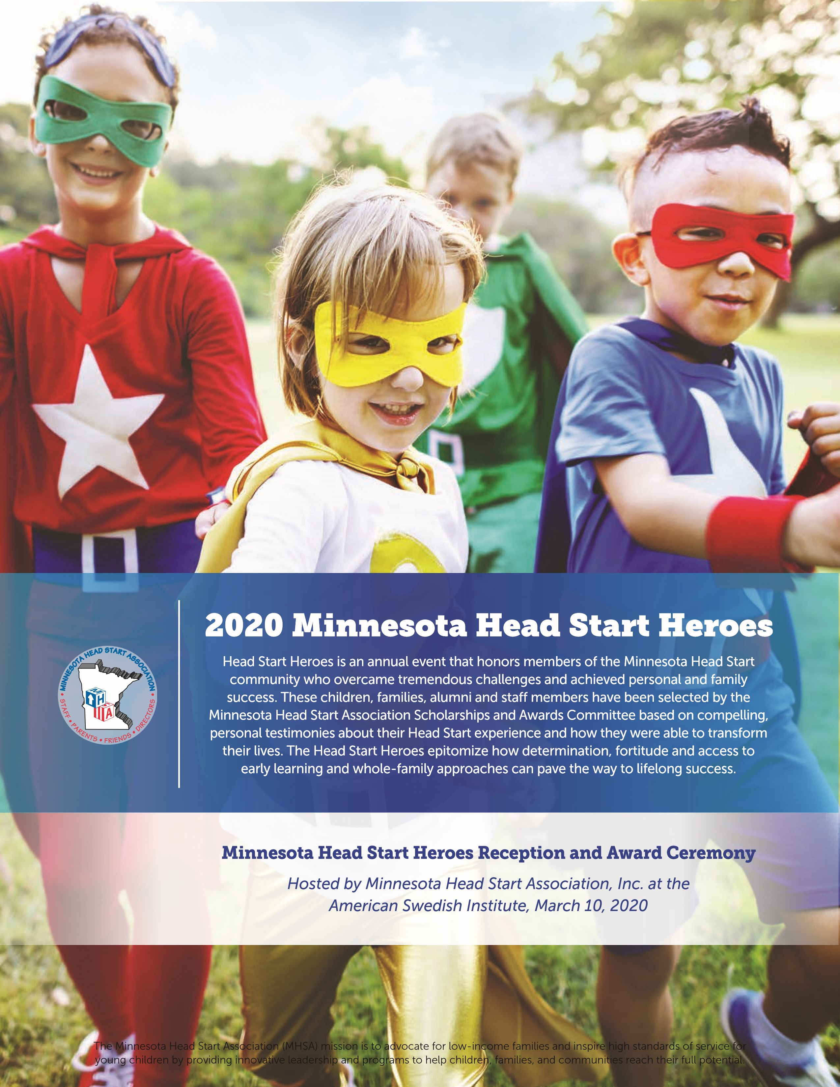
C A T E G O R Y 1 : S T A F F M E M B E R
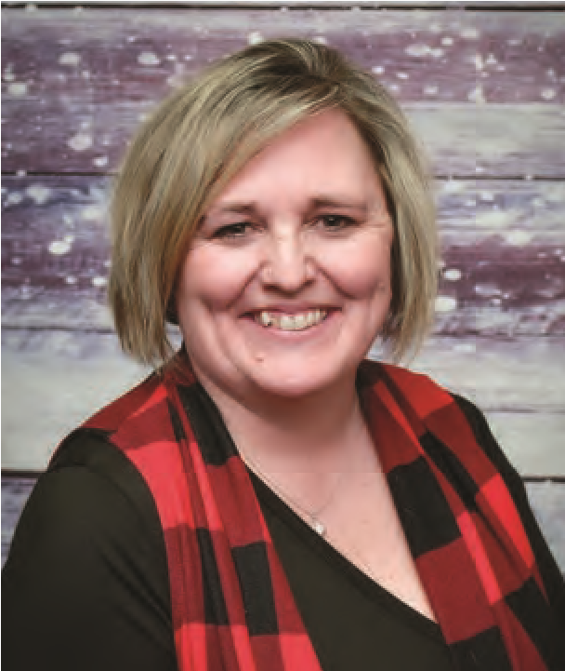
Head Start alumni (parent/guardian or child) who has become involved in their local program as a staff member of some type, and demonstrates a passion for serving through advocacy, career growth, or being involved in Head Start, the community, or the state/national level that benefits Head Start families.

Melody Hedden

Tri-Valley Opportunity Council, Inc.

Head start is the foundation from
which my life skills were built, it
became my security blanket. Born
into a family stricken with poverty
wasn’t easy. I was the daughter of a
farmer who battled with alcoholism,
and his wife that took on jobs to help
ends meet. I didn’t realize how poor
we were until my adult years. As
hard as those years were, I wouldn’t
change anything.
When I think back to those years,
I remember Mrs. Ollie coming to
my house. I didn’t realize she did
home visits with all the kids in her
class. I always thought she came to
my house because I was her favorite.
One incident I remember in particular
is Ms. Ollie talked my dad into
volunteering at the center. I wasn’t
sure how she did that as my dad
was a very shy man.
After I aged out of Head Start,
I would be struck by several tragic
events including the suicide of my
father. I felt my life was spinning
out of control for some time.
I eventually graduated high school
and married. We began to have
children and I began to think back
at my own childhood experiences.
I signed my own children up for
Head Start, volunteered in their
classrooms accompanying field
trips and doing activities at home
with them. I began to realize how
important my future was because
my children’s future largely
depended on me.
While my children were in Head
Start they received services that
would later change their lives.
My oldest, who was shy and unsure
of himself, is now a Drill Sergeant in
the Army. My daughter, who was in
the speech program, is now a Welder
in the Navy. My youngest was
referred for lots of testing by Head
Start and, while in the program,
we learned that he needed glasses,
tubes, and had a brain tumor. He
and his dad now have their own
excavating business. Their time in
the program was priceless. No one
had to sell me on Head Start being
the best start.
I started my career in Head Start as
a Family Advocate in June 1999.
I can recall telling a coworker,
“I can see myself retiring from a
job like this.” While at Head Start
I earned my associates degree,
obtained the Family Service
Credential, was awarded Family
Advocate of the year for North
Carolina in 1999, was promoted to
ERSEA Specialist in 2000. In 2014,
I moved my family to MN to work
as a Family and Community Services
Manager. In 2019, I was promoted
to Assistant Director of Program
Services. As you can see, I never
quite let go of that security blanket
I call Head Start.
It is my mission to foster life-
changing events in the lives of
children and families that I work
with. I do this not only through my
work with Head Start but serving
my community as a foster parent.
Children need us to believe in them;
after all, they are the key to our
future. My career began and will
end with Head Start. What better
way to make a difference in the
lives of others than to help them
build a strong foundation.
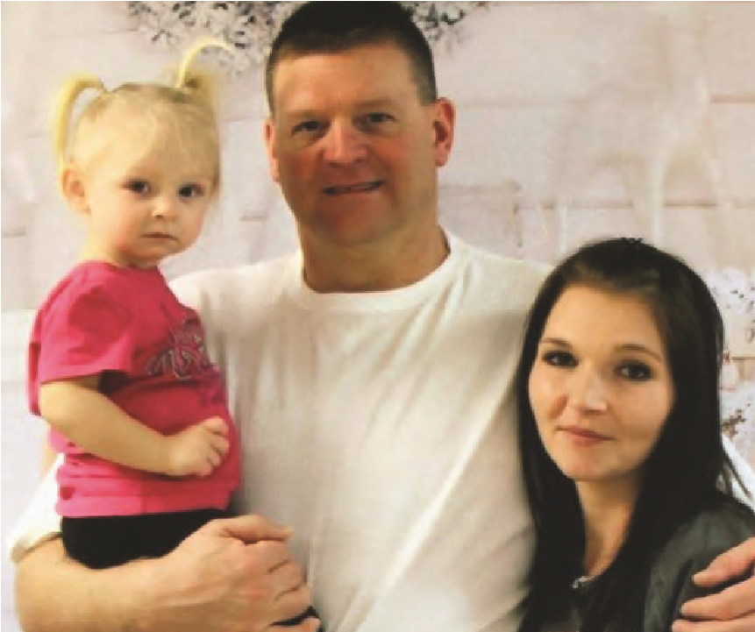

Michele Fornshell

Community Action Partnership, Lakes and Prairies
I first met Michele and her daughter
Memri during our Head Start
Screening Days. When they arrived,
I could tell Michele was very nervous,
but she was also kind and polite.
During our first week of home visits
Michele started to open up about her
past life, a victim of child abuse, a
drug addict, loss of custody of her
child, in juvenile detention & jail,
and homelessness.
She later married and had three
children and then divorced. and
went through gastric bypass surgery.
Michele spoke openly about losing
custody of her daughter Memri as
a newborn, after she was born with
meth in her system.
Michele worked hard to become clean,
re-gained custody of her daughter and
her life. I remember being in awe of
how open and honest Michele was
with me all while being so positive
about her life.
Michele shared her biography she
wrote while in treatment. I remember
sitting on my couch, reading her story
and sobbing. It made me realize how
strong and resilient Michele has been
from the moment she was born. While
many people suffer traumatic events,
Michele had lived with trauma her
whole life.
Since the day Michele got her
daughter back, she has made her life
focus to have a heathy family that
strives on positive relationships and
education. Michele had services from
Public Health in place, but signed
Memri up for Early Head Start, eager
to take advantage of all the support
she could get.
Michele comes to Head Start Group
Socializations, serves on Policy
Council, was elected Policy Council
Treasurer, got a job, found childcare
for Memri and went to work. She
recently was promoted at her job,
continues to be very involved in
Head Start and signed Memri up for
gymnastics to get more socialization
with other children. Michele
negotiated with her supervisor to make
sure that she will always have each
Tuesday off to have time for Memri’s
Early Head Start Home Visit. It is so
important to them and keeps Memri’s
development on track.
Michele is the living proof that you
can do anything you want, no matter
your past choices, as long as you are
determined, work hard and believe in
yourself. Michele is truly my hero.
CATEGORY 2: FAMILY SUCCESS
Head Start family who has made significant life changes within
the past 12 months and is currently enrolled in a Head Start or
Early Head Start program or is serving on a Policy Council.
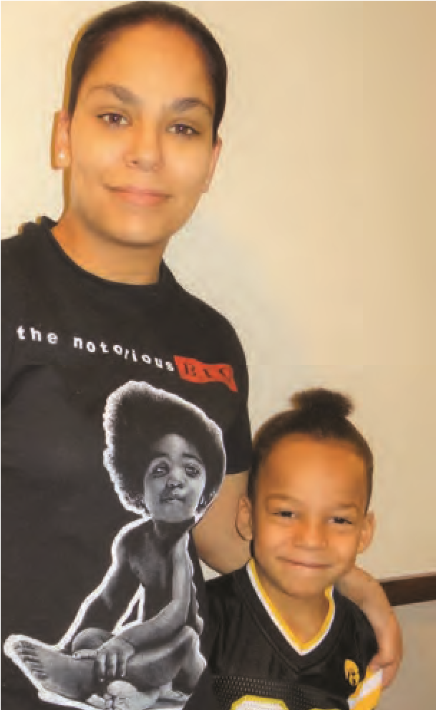
CATEGORY 3: CHILD SUCCESS
A currently enrolled Head Start or Early Head Start child who
has made tremendous developmental progress while enrolled
in a Head Start / Early Head Start program.

Tyrese Sulemani

Community Action Partnership, Lakes and Prairies
Tyrese came into Head Start with
a lot of trauma and a chip on his
shoulder. He lashed out at teachers
and friends verbally and physically.
Tyrese was unable to trust or comply,
making sitting for lessons or learning
to play with his friends a seemingly
unreachable goal. Underneath his
trauma and behaviors, however, you
could already see the smart, loyal,
and social child wanting to come out.
The difference from when I first
met Tyrese to where he’s at today
is night and day. While he once
communicated through hitting,
cursing, and yelling, Tyrese, now,
often uses incredibly insightful and
polite words. While he once was
filled with uncontrollable emotion,
Tyrese can now recognize his
emotions and handle them before his
feelings escalate into a runaway train.
This allows teachers and his peers to
see the profound kindness Tyrese
is capable of, his steadfast loyalty,
his quick wit and problem solving.
What we are, perhaps, the proudest
of are his developmental gains,
especially Tyrese’s play with his
peers. His friends have gone from
being afraid of Tyrese and his anger,
to loudly proclaiming to their parents,
“Tyrese is my friend!” He comes up
with the most fun games to play and
has encouraging words for friends
who are struggling. Tyrese has turned
into a friend who is excellent at
sharing everything from toys to the
stickers that he gets as a reward for
his behavior. Hands that were used
for hitting now give hugs and
high fives.

We still have a lot of work to do,
but Tyrese’
s incredible improvement
makes all of us who are fortunate
enough to work with him excited
to see what is next. Tyrese is
growing so fast and really
overcoming the odds. I’m sure
our next challenge will be keeping
up with his new found skills.
Instead of being on a “runaway
trauma train” Tyrese will be on
track for success in kindergarten.
C A T E G O R Y 4 : L O C A L A D V O C A T E
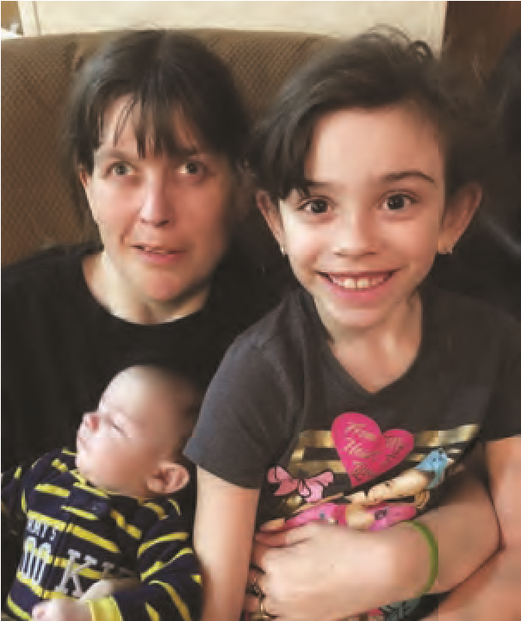
A Head Start alumni (parent/guardian or child) who has demonstrated advocacy by becoming involved in their local program or community, such as Policy Council, their agency’s governing body (Board of Directors), a parent committee/board at their public/private school, leadership in a local organization, etc.

Tiffani Ruiz

Mahube-Otwa Community Action Partnership, Inc.
Tiffani reports that their family has
learned so much over the years. She
said, “the children are our future.”
Tiffani started her involvement as a
child in the program, but continues
now as a parent.
Tiffani has been a member of
Policy Council for 4 years. She
is currently serving as our Policy
Council secretary. Tiffani stated that,
at first, she was not very excited
about Policy Council. But her home
visitor said she would be great at it.
With encouragement, she came out
of her shell and joined the Policy
Council. She was elected as a liaison
from Policy Council to our Board
of Directors, attending monthly
meetings. Our Executive Director,
stated, “She not only attends Board
meetings regularly, but she is actively
involved in the meetings.”
Tiffani believes her husband, Ryan,
has come out of his shell too. With
the help of Head Start, he is very
willing and excited to attend Head
Start events, read to the kids, and
take part in community activities.
One of her children’s teachers
remembers “They, the Ruiz family,
attend everything. I always set aside
an hour for their conferences. They
liked to get the conference report a
week ahead of time. Then, during the
conference, they would come with
a list of questions. We took lots of
time to go through the questions.”
The teacher also shared, “Once,
Tiffani was home with a broken leg.
Ryan taped the conference on his
phone. She was able to be part of
the conference even when she was
not physically present for it.”
Tiffani is the main care taker in the
home. Tiffani continues to overcome
CMT (Charcot-Marie-Tooth Disease).
This disease affects the nerves in her
hands and legs and has left her in
a wheel chair. Tiffani lost her sight
in 2005. The doctors are not sure if
the loss of sight and the CMT are
connected. Ryan and Tiffani support
each other through all their challenges.
Ryan arranges his work schedule to
assist her in her transportation needs.
They attend home base socialization
on a regular basis. Ryan also drives
Tiffani to all the Policy Council and
Board meetings and other family
events for Head Start.
C A T E G O R Y 5 : P A R E N T S C H O L A R S H I P
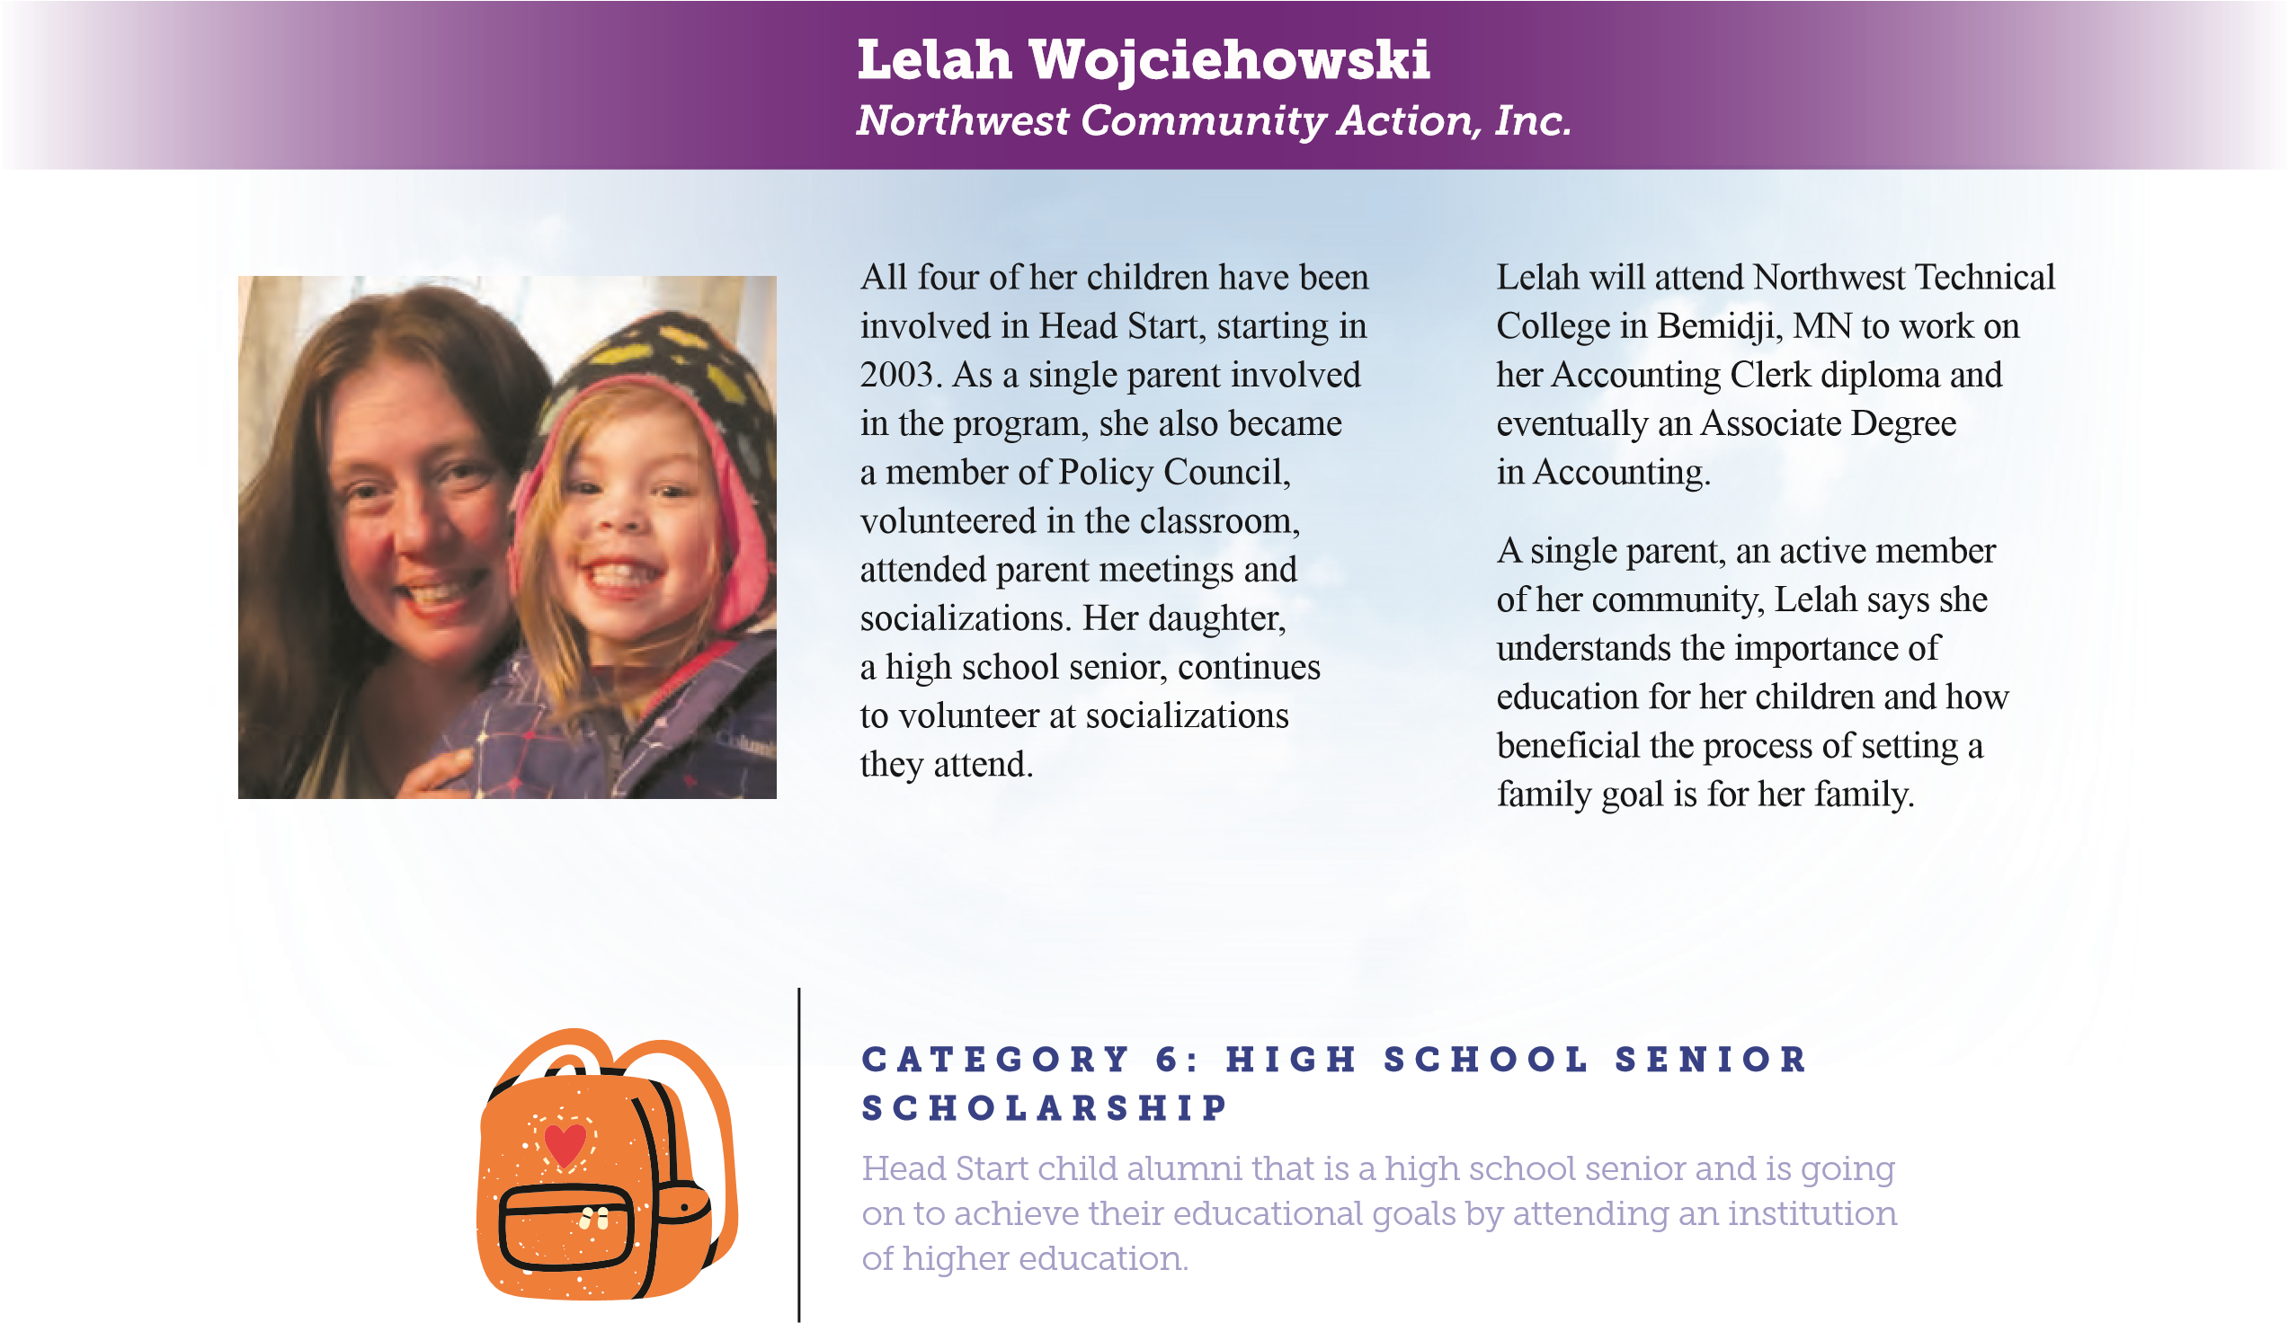
Person that is a Head Start child alumni or current/past parent that is going on to achieve their educational goals by attending an institution of higher education.

Diana Salazar Cervantes

Tri-County Community Action Partnership
After coming to the U.S., learning
English, my parents worked very hard
to provide for my family, making sure
we had early exposure to education.
As a child in Head Start, it played a
big role for me to learn the English
language and become prepared for
Kindergarten. I have observed the
impact the program has had on my
parents and three younger sisters,
the same program that made such
an impact on me. I attend my sister’s
family events and Head Start activities,
play basketball and volleyball, run
track, and am a teacher assistant in the
2
nd grade classroom. If awarded, this
will help me so that I can continue my
education in Early Childhood and give
back to Head Start.
Diana will attend Alexandria Technical
and Community College to study
Early Childhood Education.
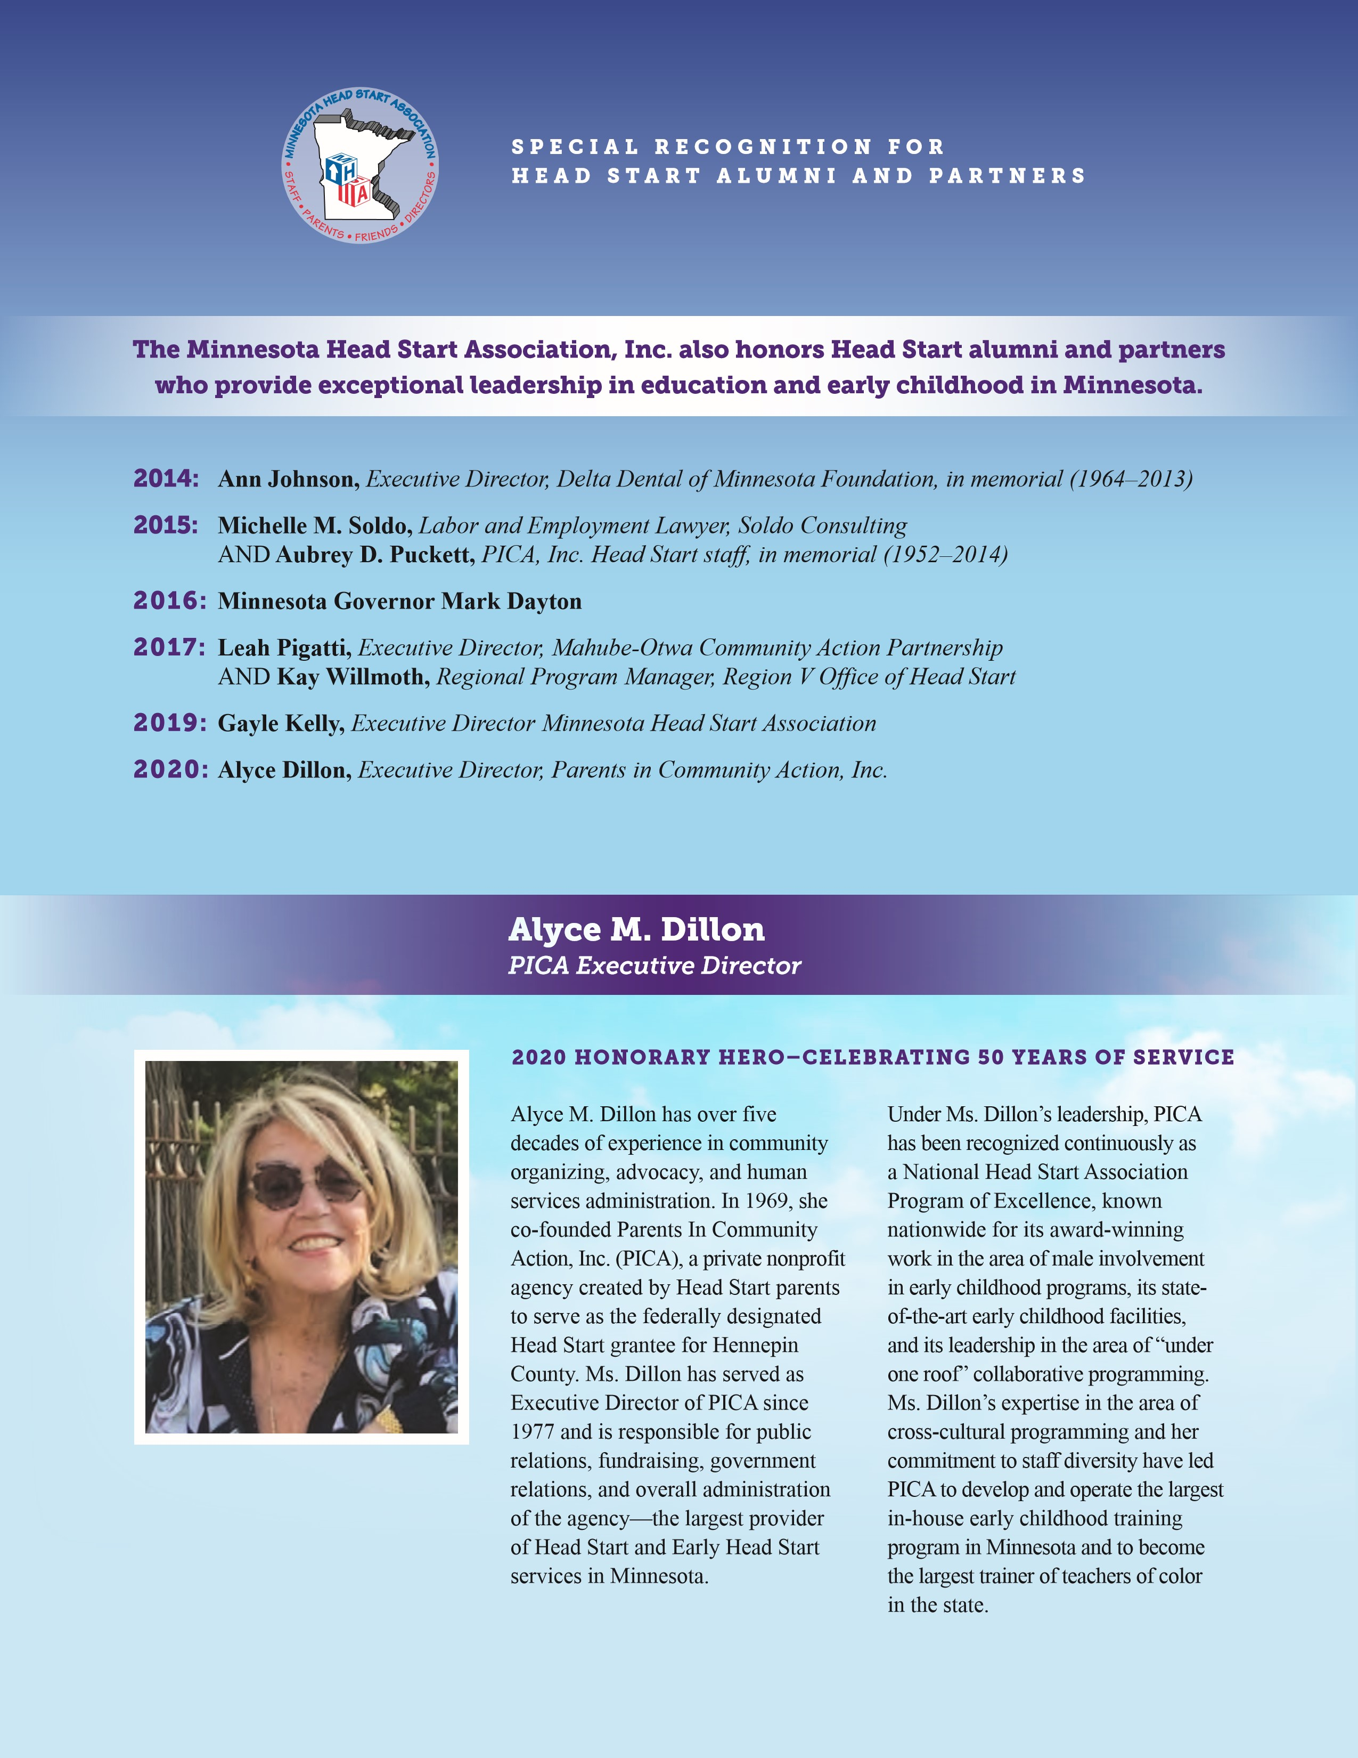

We would like to acknowledge those listed below who applied and were considered for the Head Start Heroes Awards but were not selected. Every story was unique and inspiring, making the decision very difficult. On behalf of children and families across Minnesota and the nation, we thank you for your passion and advocacy, as it truly demonstrates that Head Start works!

CATEGORY ONE: STAFF MEMBER
Head Start alumni (parent/guardian or child) who has become involved in their local program as a staff member of some type, and demonstrates a passion for serving through advocacy, career growth, or being involved in Head Start, the community, or the state/national level that benefits Head Start families.
> Zoe Carlson, Bi-County Community Action Programs
> Zejna Medar, Families First of MN
> Sara Paolo, Arrowhead Economic Opportunity Council
> Anne Unze, United Community Action Partnership

CATEGORY TWO: FAMILY SUCCESS
Head Start family who has made significant life changes within the past 12 months and is currently enrolled in a Head Start or Early Head Start program or is serving on a Policy Council.
> Joe & Jessica Dickson family, Mahube-Otwa Community Action Partnership
> Lyndsie Hariluk & Ernesto Leon family, Inter-County Community Council
> Ragan Johnson family, Families First of MN
> Tamisen Johnson family, Inter-County Community Council
> Kathy Naglel family, Arrowhead Economic Opportunity Council
> Kathryn Ryan family, Lakes and Pines Community Action Council
> Pat & Chastin Shaw family, Tri-County Community Action Partnership
> Amanda Stevens family, Arrowhead Economic Opportunity Council
> Ariel Westad family, Tri-County Community
Action Partnership

CATEGORY THREE: CHILD SUCCESS
A currently enrolled Head Start or Early Head Start child who has made tremendous developmental progress while enrolled in a Head Start/Early Head Start program.
> Stephen Gehrig, Community Action Partnership, Lakes and Prairies
> Maverick Shaw, Tri-County Community
Action Partnership
Minnesota Head Start Association, Inc.
PO Box 27851, Minneapolis, MN 55427-9998 o: 763.208.7272 c: 763.544.1992 www.mnheadstart.org

CATEGORY FOUR: LOCAL ADVOCATE
A Head Start alumni (parent/guardian or child) who has demonstrated advocacy by becoming involved in their local program or community, such as Policy Council, their agency’s governing body (Board of Directors), a parent committee/board at their public/private school, leadership in a local organization, etc.
> Cristina Cummins, Tri-County Community Action Partnership
> Kala Sawyer, Tri-County Community Action Partnership
> Corrina Spears, Bi-County Community Action Programs
> Kristina Stone, Tri-County Community Action Partnership

CATEGORY FIVE: PARENT SCHOLARSHIP
Person that is a Head Start child alumni or current/past parent that is going on to achieve their educational goals by attending an institution of higher education.
> Tiffany Barrone, Semcac Community Action Agency
> Leslie Diazlopez, Minnesota Valley Action Council
> Kayla Heino, Arrowhead Economic Opportunity Council
> Ragan Johnson, Families First of MN
> Kortney Johnson, Fond du Lac Head Start
> Jenny Kankel, United Community Action Partnership
> Kelsey Lofgren, Inter-County Community Council
> Joanne Paquette, Bi-County Community Action Programs
> Kathryn Ryan, Lakes and Pines Community Action Council
> Derek Rygh, Tri-County Community Action Partnership > Nicole Theisen, Fond du Lac Head Start

CATEGORY SIX: HIGH SCHOOL SENIOR SCHOLARSHIP
Head Start child alumni that is a high school senior and is going on to achieve their educational goals by attending an institution of higher education.
> Kiana Anderson, Bi-County Community Action Programs
> Matthew Andresen, Mahube-Otwa Community Action Partnership
> Jaime Eischens, Mahube-Otwa Community Action Partnership
> Maggie Hedstrom, Mahube-Otwa Community Action Partnership
> Jalayana Kelley, Inter-County Community Council
> Kayden Kenfield, Inter-County Community Council
> Adison McCollum, Inter-County Community Council
> Lindsay Person, Mahube-Otwa Community Action Partnership
> Tanisha Srnsky, Inter-County Community Council
> Jackie Taflin, Inter-County Community Council
> Kansas Tilbury, Bi-County Community Action Programs
> Natalia Whalen, Inter-County Community Council
> Destiny Wojciehowski, Northwest Community Action

